Study of solid waste in the Western Mediterranean seabed
(Times 16, Bold)

Fatima Kettani¹ *, Ahmed Bnnani¹, Fahd Alaoui¹, Amal Limane², Mohamed Boujadi¹ & Ali Daoudi¹
(Times 12 Bold; First name + Last name -small caps-, Arabic numbers: affiliation, star: corresponding author)

1. Address
2. Address
(Affiliation : Times 10)

Abstract. This study analyses the impact of oceanic circulation on the spatial distribution ... (Times 10; bold for Abstract, normal for text, line spacing 1. Total words between 250 and 300)
Keywords: marine debris, seafloor, oceanic circulation, GIS, Moroccan Atlantic Ocean ... (Times 10; bold for Key words, normal for text, Total keywords between 5 and 7)

1. Introduction (Times 12)
(Texte en Times 11, interligne 1,15, espace fin paragraphe: 6 pts) Solid marine wastes correspond to all the objects or materials that are, …
2. Materials and Methods (Times 12 Gras)
2.1. Study area (Times 11 Gras)
The Moroccan Atlantic coast is part of the Canary Current Large Marine Ecosystem (CCLME) which extends from the Iberian Peninsula (43°N) to the south of Senegal (8°N); CCLME is one of the world’s four major Ecosystems (Barton et al. 1998) (Fig. 1).
Author quotations in the text: first author, first letter capital, the rest in small caps (select the author, then Format, font, small caps). If two authors put : Auteur1 & Auteur2, followed by the year of publication. Several authors put Auteur 1 et al, followed by the year of publication).

Examples: According to the Keller et al. methodology (Loulad et al. 2017; Stramma & Siedler 1988), these debris were separated and classified.

2.2. Database (Times 11, bold)
2.2.1 Marine debris (Times 11, bold)
This study’s seafloor marine debris database comes from four trawling surveys carried out …

3.1 Density
Densities were expressed as individuals per cubic meter (ind. m⁻³). They were calculated as follows:
$D=\frac{\left(n*1000\right)}{V}$ (1)
Where:
D is the density (expressed in individuals per liter),
n is the number of individuals found per volume of water and,
V is the filtered water volume (m³).

Finally, due to its relevance for water planners, we also estimate the change in available soil water content (aridity) under drought condition as:
$Δx_{T_{Δ}}=F_{T_{Δ}}^{-1}\left(0.2\right)-F_{T_{0}}^{-1}\left(0.2\right)$ (2)
$F^{-1}\left(0.2\right)$ is the soil moisture value corresponding to the 20th percentile during a given period (warming $T_{Δ}$ or historical $T_{0}$ for each cell, RCP, and LSM-GCM combinations. $∆x$ is reported as seasonal averages of the estimated values for each month. The results are represented by the average over all the cells within a given catchment.

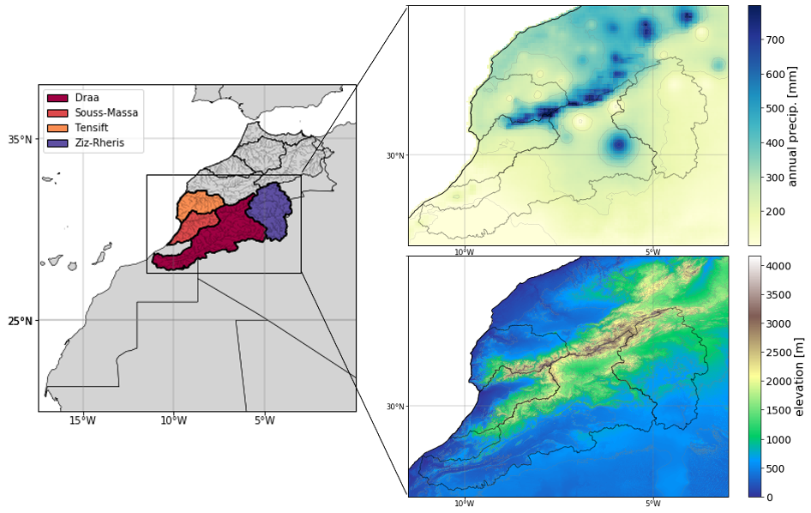
Figure xx: Localization of the Moroccan Atlantic coast (study area). (Times 10, centered)
The figures are edited either in a 16 cm column or in a 7.8 cm column. Please take into account the reduction of the edition for the legibility of the toponymies and figures.

Table 1: Explored stations between 2011-2018 along the Moroccan Atlantic coast (Times 10, centered)
Surveys | Surveys date | Number of explored stations | Spatial coverage | Depth (m)
2000 | June 2000 | x | x | x
2010 | October 2010 | x | x | x

Or

years | Surveys | Number | coverage | Depth
2011 | x | x | x | x
2014 | x | x | x | x

years | Surveys | Number | coverage | Depth
2011 | x | x | x | x
2014 | x | x | x | x

2.3. Methodological approach ((Times 11, bold)
To analyze the seafloor marine debris data, we proceeded as follows:
- ….
- ….
- …..
3. Results (Times 12, bold)
To analyze the spatial distribution. ….

Using groups of 5 years, we calculated the moving average of the maximum and minimum temperatures (Fig. 5) ….
In Figure 5a, the trend declines very softly throughout the years, as the first and last maximum temperatures are very close; they are both limited between 28 °C and 29 °C. On the other hand (Fig. 5b), an evident increasing trend in minimum temperatures with a variation of 3.36°C was noted.
Figure xxxx. Moving average temperatures (a) Maximum temperatures (b) Minimum temperatures

4. Discussion (Times 12, bold)
We conducted Bottom trawl surveys to map …

5. Conclusion (Times 12, bold)
Our study allow to. ….
Acknowledgements (Times 12, bold)
The authors thank …..

References (Times 12, bold)

References should be presented as follow: (Times 10, space 1, 6 pts after citation)

Andrady, A.L. (2011): Microplastics in the marine environment. Mar. Pollut. Bull., 62, 1596–1605. http://dx.doi.org/10.1016/j.marpolbul.2011.05.030.
Batten, M., Martinez, J.R., Bryan, D.W. & Buch. E.J. (2000): A modeling study of the coastal eastern boundary current system off Iberia and Morocco. Journal of Geophysical Research, Vols. %1 sur %2, 105, 14173-14195.
Stramma L. & Siedler G. (1988): Seasonal changes in the North Atlantic sub-tropical gyre. Journal of Geophysical Research, vol. 93, 8111-8118.
UNEP (2009): Marine Litter: A Global Challenge. Nairobi: UNEP, 2009, 232 p.

